SQL Server 2014 Express Installation and Configuration

Download the installation files from <https://www.microsoft.com/en-us/download/details.aspx?id=52679>

then run ***SQLServer2016-SSEI-Expr.exe*** to extract the files and begin the installation.

When the install dialog appears (it usually takes a few seconds to appear) click “New SQL Server and stand-alone installation or add features to an existing installation”.

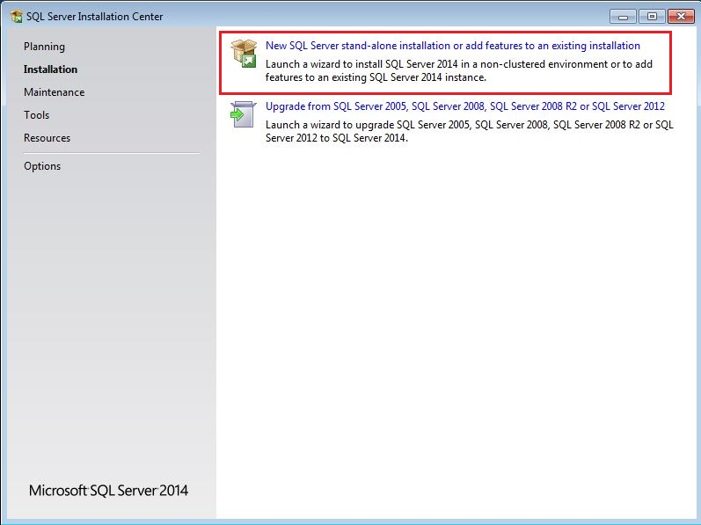

Accept the license terms and click “Next”.

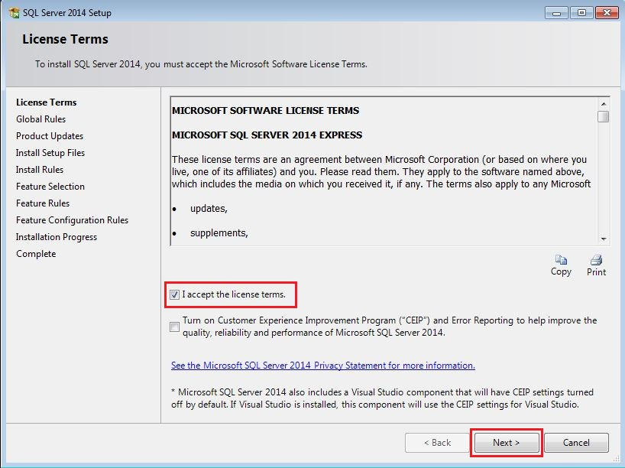

Click “Select All” for **Feature Selection** (unless all the features are already selected) then click “Next”. If *Management Tools* is not available in the list of features, cancel the entire installation and contact me.

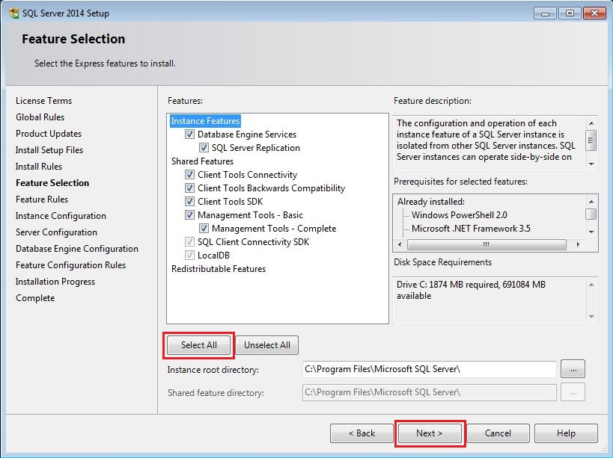

Leave the defaults for **Instance Configuration** and click “Next”.

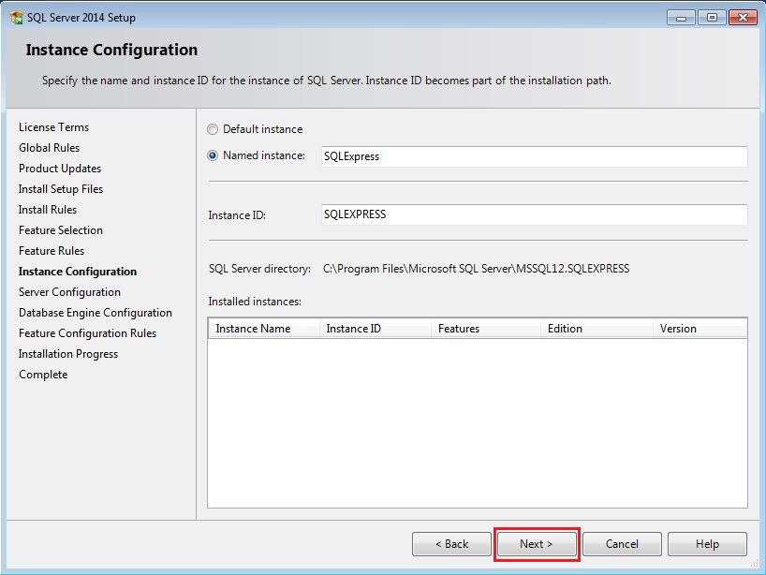

Leave the defaults for **Server Configuration** and click “Next”.

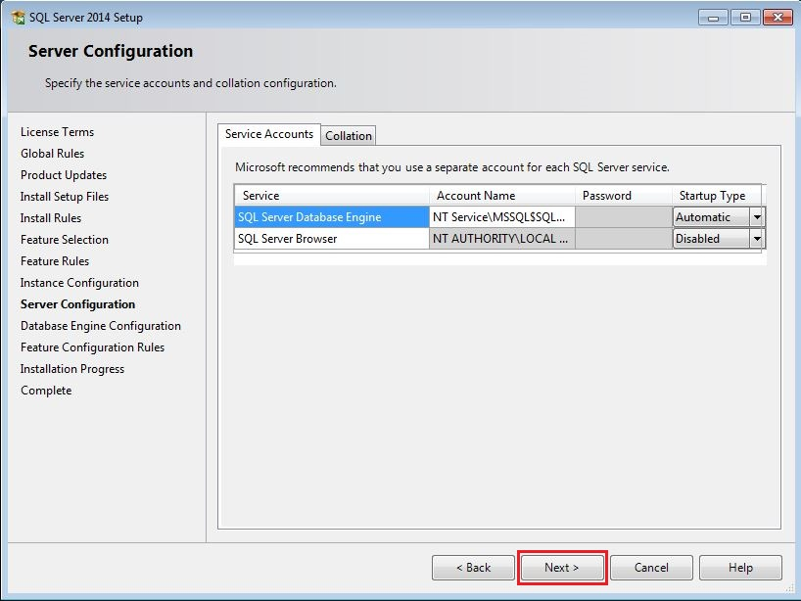

In **Database Engine Configuration** select “Mixed Mode (SQL Server authentication and Windows authentication)” for the Authentication Mode on the “Server Configuration” tab (note that the screenshot below was taken before this option had been selected). If necessary enter in a password for the “sa” user, then click on the FILESTREAM tab.

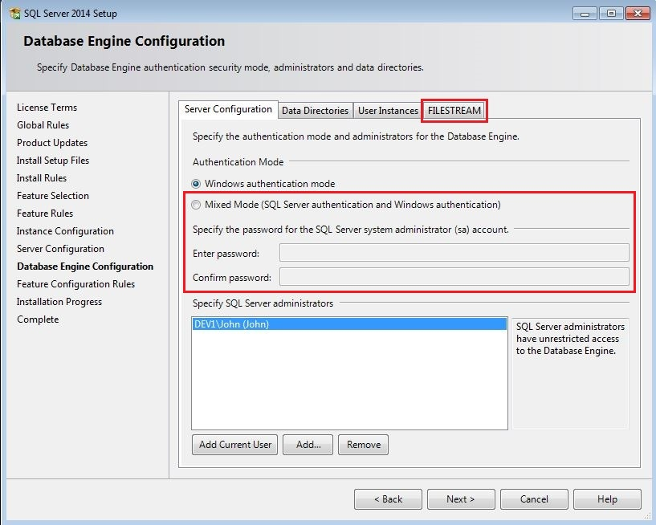

In the FILESTREAM setup, check all the available options and click “Next”.

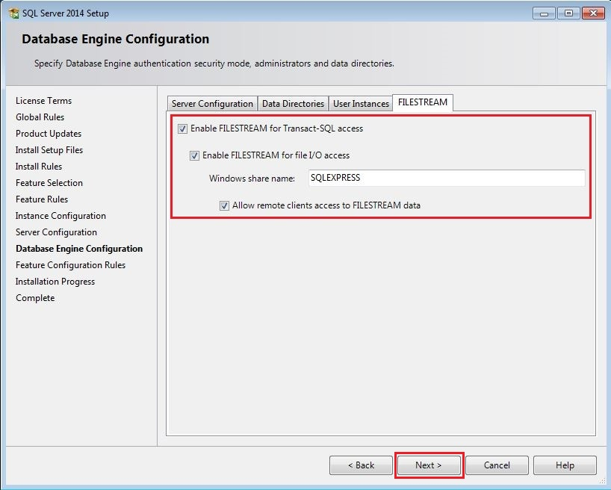

Pour yourself a coffee and share a few laughs with coworkers while the installation proceeds.

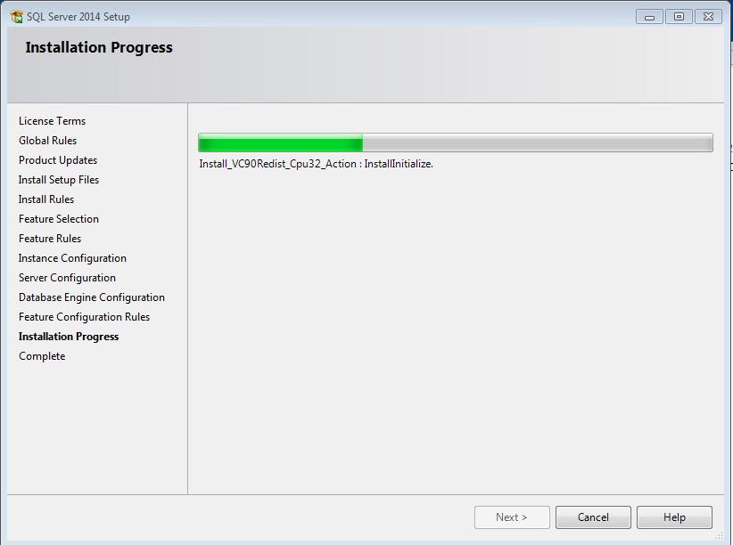

If the **Complete**dialog appears and reports a successful installation, click “Close”. If there are any failures, contact me.

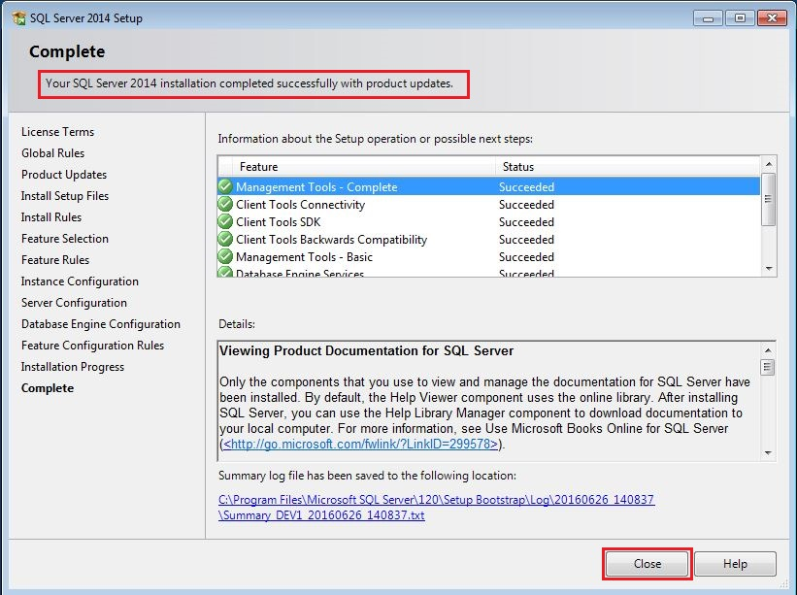

Find **SQL Server 2016 Management Studio** in your Windows Programs (should have this icon ). It will prompt for credentials (instead of “DEV1” it will show your computer name). Leave all the defaults and click “Connect”. Once it is open, pin it to your taskbar as it will get used often.

